**Gig Central Installation Guide**

1. Download Codeigniter app and unzip to desktop:

<https://www.codeigniter.com/>

1. Clone the gig-central application from repo using the Github Desktop App:

<https://github.com/newmanix/itc260-sp15-gig-central>

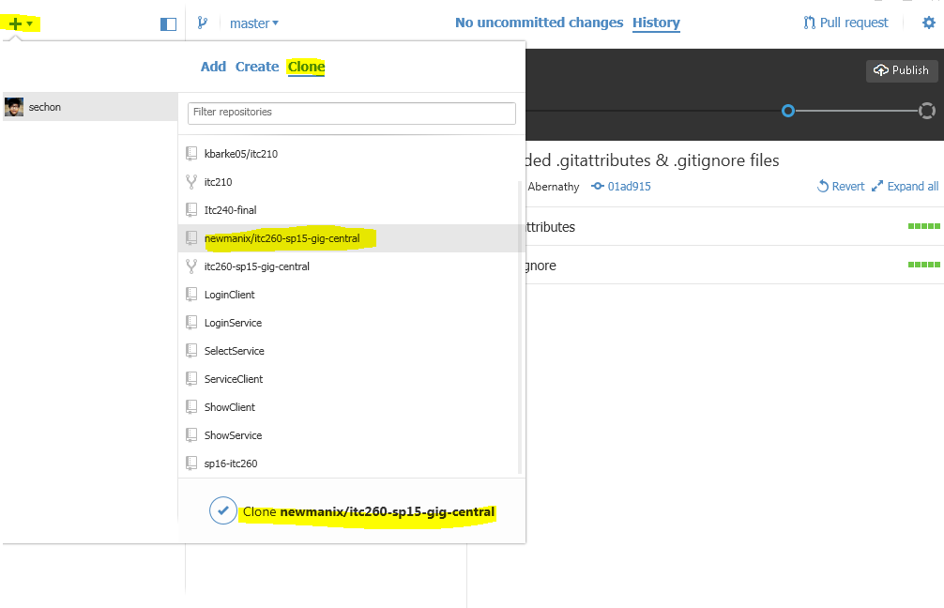

*In order for you to be able to clone the gig-central app you need to be added as a contributor.

1. Create gig-central Folder for on your deployment domain:

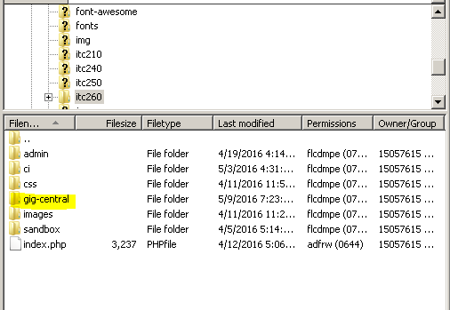

1. Upload Codeigniter files into gig-central folder first:

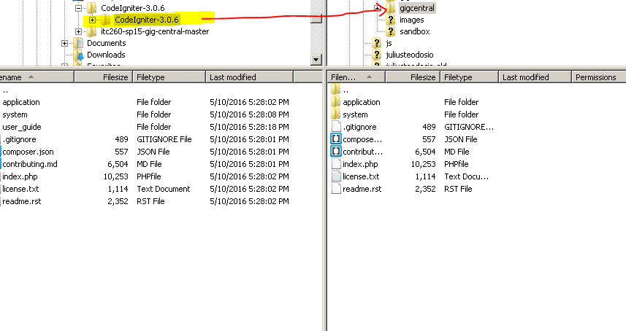

1. Then upload the Repo files into gig-central folder and replace all files:

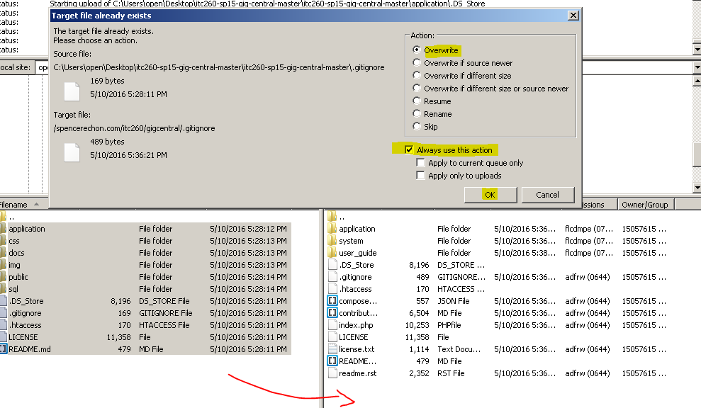

1. Open browser and test your URL:

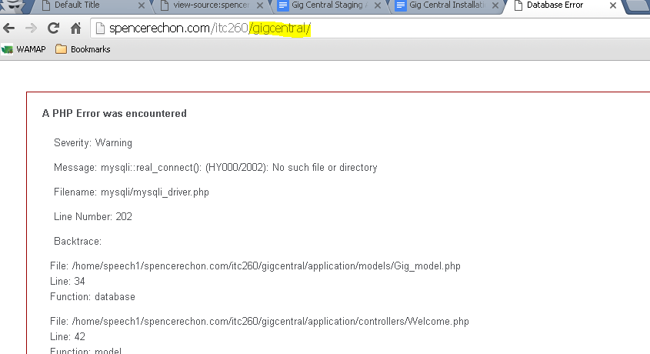

*Error telling us to set up the database.

1. Download database.php from server to your local repo folder:

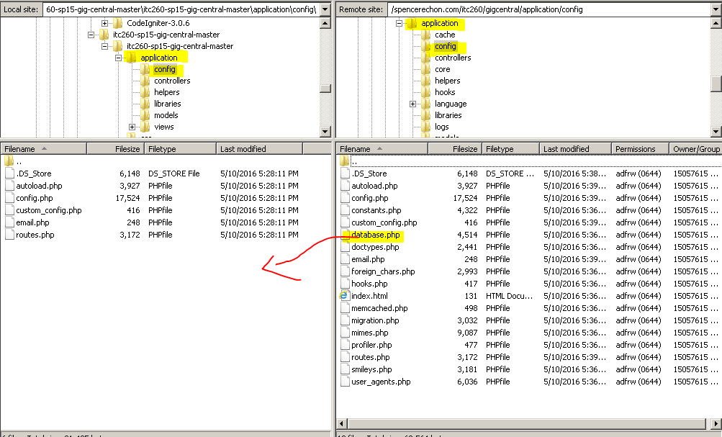

1. Open database.php in your code editor and fill in your credentials:

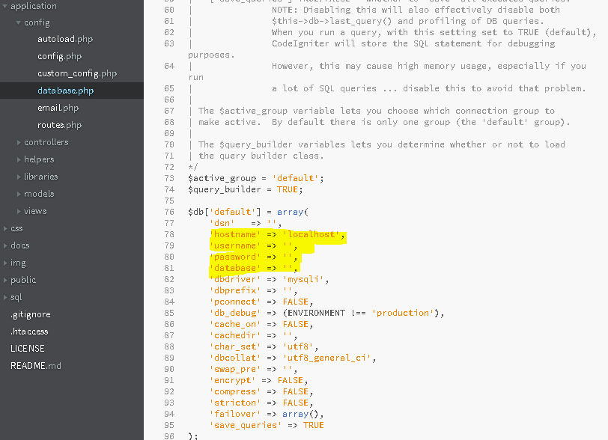

1. Open application/config/config.php and fill in your base URL:

***$config['base_url'] = 'http://domain.com/paths-to-your-gig-central-folder/';***

1. Upload the files that were changed:

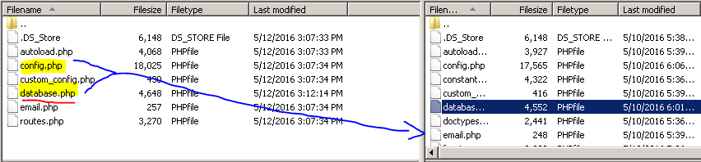

***\*Delete the database.php file from your local after, so it doesn’t commit to the main repo!***

1. Go to application/config/recaptcha_example.php

Copy recaptcha_example.php to recaptcha.php and edit this new file  
(the original recaptcha_example.php will be ignored; don't change this just to configure your site. Change it only if you are developing the application)

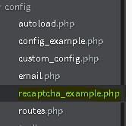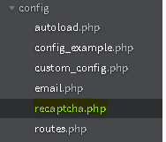  
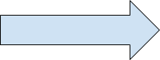

1. Go get your recaptcha keys:

<https://www.google.com/recaptcha/intro/index.html>

https://lh3.googleusercontent.com/Mh3DkEozfdKexgT3_PO1zyMDy6Y3g2AqrkbAaxlYv-mZK5g0hXmerOud3mRM4BSBIt8vTWKPXkTx2SQEeTbf8_8F8QOz3rzatNJbxUcHd4DApaSUikgJFujuPaMiVZq7CfC7vFVT

-Register the domain that this instance of gig-central is/will be located in

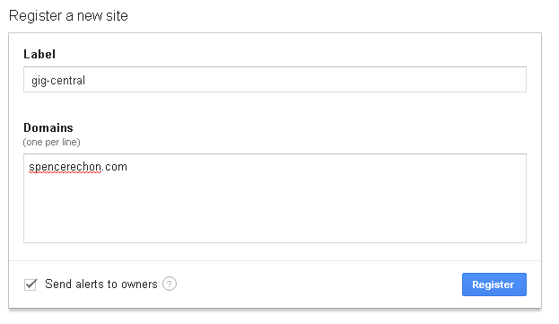

-Copy site key and secret key

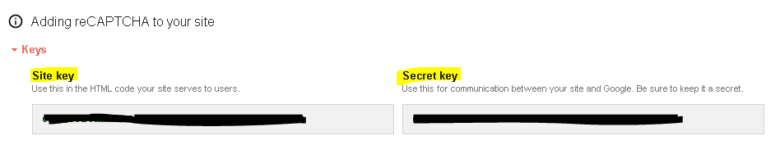

1. In the copied recaptcha.php file, insert keys from google then upload:

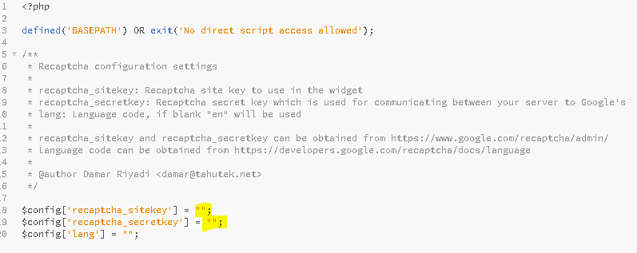

1. Copy config/email_example.php to config/email.php and fill in the appropriate values for email usage. In particular, fill out the following:

* $config['protocol'] and the various $config['smtp_*******'] values should be set to the appropriate SMTP settings provided by your webhost or bulk-email service (if you are using one). **If you do not do this, Gig Central will be unable to send *any* email!**
* $config['email_contact_sendto'] should be set to a monitored email account used to handle user inquiries sent from the website.
* *Some email services (eg, GMail) will not allow a custom "From" address, and will send all emails under the name of the account used to send the email. In these cases, $config['autoemail_from_address'] will have no useful effect.*

1. Go to your MySQL manager (Adminer/PhpMyAdmin/etc) and import sql file from sql folder in the root of gig-central.

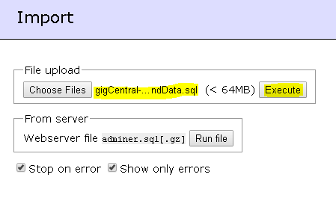

1. Go to your URL and everything should be running!

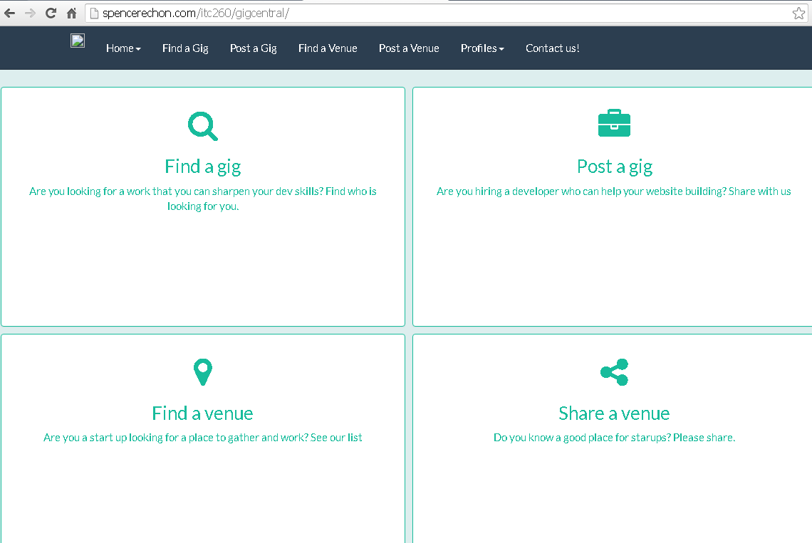

Tips:

* Database Errors:
  + Make sure you remove your database.php file locally before you publish on github to protect your credentials.
  + Verify that the database credentials in database.php are correct
  + Ensure the Gig Central SQL file has been installed correctly
  + Verify that the SQL file is being applied to the correct database (eg, applying it to DB sp16_somethingelse, when database.php specifies the DB sp16_gigcentral)
* CSS
  + If the application's main page does not load correctly and instead appear similar to the figure below:

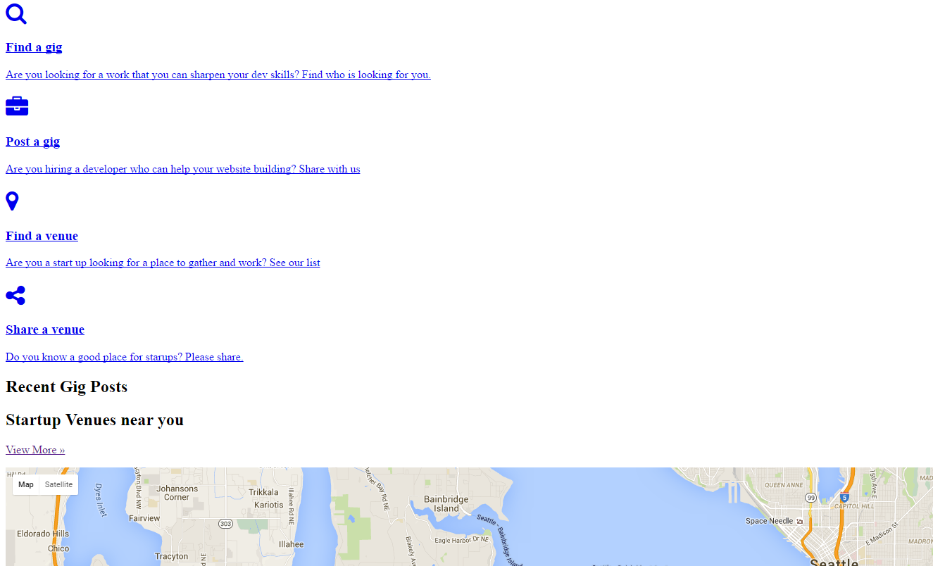

...go to the folder where Gig Central is installed and make sure the **public** folder exists in the same level as the **application** folder (like in this picture):

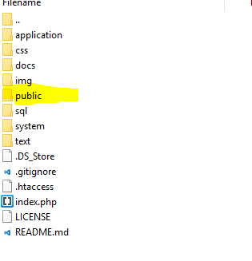

No recaptcha file found:

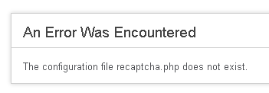

Make sure the recaptcha config file has been filled out with the appropriate values, and copied to config/recaptcha.php